# http://www.onaway.org/animal/images/grizzly_bear2.jpg

Berclair

Elementary School

**2021-2022 Student Handbook**

**Clinton Davis, Principal**

**Rebecca Schaffer, Assistant Principal**

**Tabitha Arnold, PLC Coach**

**Margaret Greer, Instructional Facilitator**

**Candiace Dandridge, School Counselor**

**Deandra Calvin, School Counselor**

**810 North Perkins**

### **Memphis, TN 38122**

#### Phone: 901-416-8800

**Teachers: 8:00 a.m. to 3:30 p.m.**

**Students: 7:50 a.m. enter for breakfast / 8:05 enter if not eating breakfast;**

**8:15 a.m. school starts; 3:15 p.m. dismissal**

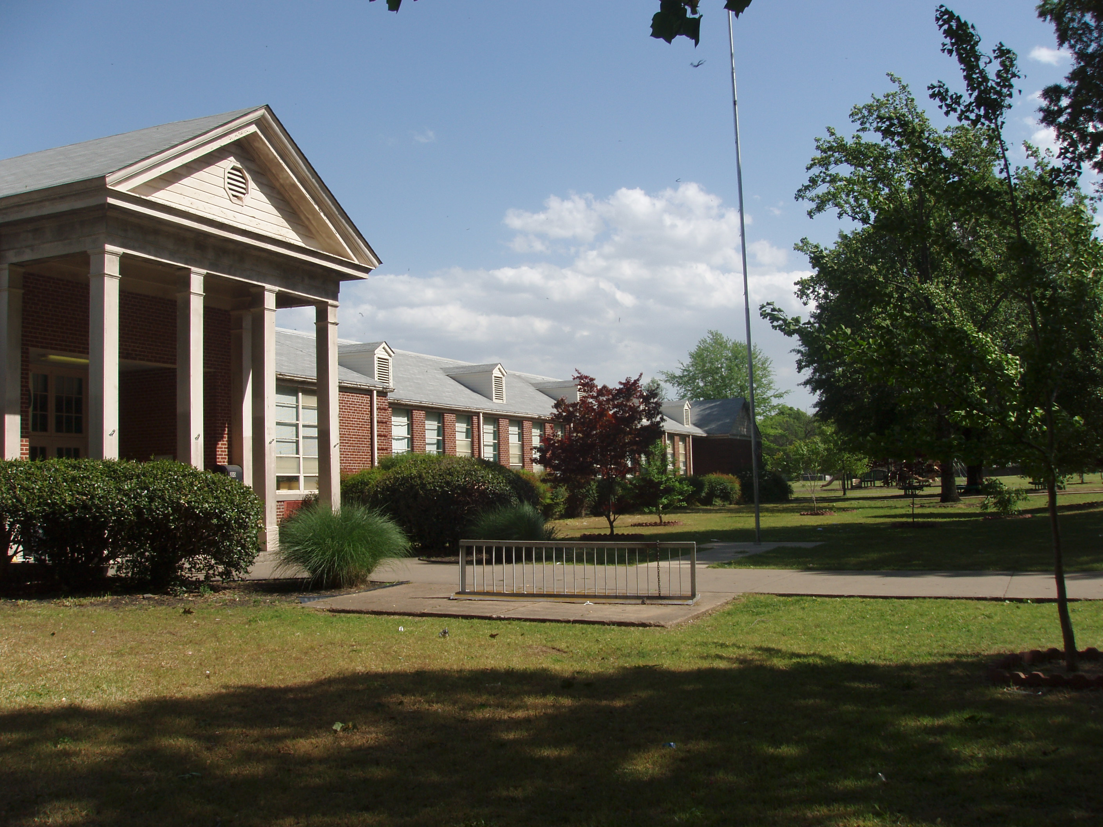

Elementary School

Berclair

Escuela Primaria

# **Berclair Elementary School**

**810 North Perkins**

**Memphis, TN 38122**

**Phone: 901-416-8800**

The faculty and staff of Berclair Elementary School welcome you and your family. We do our best to offer your child the best possible education, and we strive to make that education interesting and stimulating. We ask for your support by actively participating in your child’s education. This handbook has been carefully prepared and presented in order that students and parents may know and understand the policies and practices of Berclair Elementary School.

**Shelby County Schools does not discriminate in its programs or employment on the basis of race, color, religion, national origin, handicap/disability, sex, or age.**

**WHY BERCLAIR IS A SPECIAL PLACE FOR YOUR CHILD (CHILDREN)**

|  |  |
| --- | --- |
| **Academics** | * Berclair has demonstrated high levels of student growth evidenced by our identification as a Tennessee Reward School following the most recent TCAP test. * We have National Board Certified Teachers on staff. * We teach reading starting in Kindergarten. * Every child’s academic progress is individually supported. * The State of Tennessee lists us as a **level 5 school** where 5 is the highest possible score. * 2 Full-time counselors, 2 music and art teachers, 2 PE coaches, librarian, 8 ESL teachers, plus a large team of classroom teachers and paraprofessionals who are committed to seeing every child learn, grow, and achieve. * CLUE program is available for students who qualify * ARISE2READ program supports 2nd grade students in preparing for needed reading skills in the upper grades. * Functional Skills classes are available for students meeting the IEP requirements. * Resource classes are available for students meeting the IEP requirements. * RTI (Response to Intervention) affords every child in the school tailored instruction to improve academic areas of deficit and takes place in every classroom at the same time school-wide. |
| **Culture:** | * We respect all cultures. * Berclair represents the diverse make-up in America, * We teach in English but communicate with parents in their language as needed so they can help their children. Bilingual mentors are available for families needing assistance in communicating with the school. * Nurturing classroom environments with teachers who are committed to seeing all students succeed. |
| **Facilities:** | * We have advanced security measures and procedures to increase the **safety** of our children. * Three buildings comprise our school’s physical plant. Students are clustered in buildings by grade level. * Berclair has a gymnasium, 2 playgrounds, and sits on a large 11 acre site. |
| **After-School Activities** | Activities that have been available to students in recent years (Availability may be affected by Covid-19 protocols and limitations)   * Volunteer **basketball** team * Volunteer coed **soccer** team * Coed **dance** team * **FREE AFTER SCHOOL CARE** * Good News Club * Family Matters for 5th grade boys * Chorus * Young Astronauts Club |
| **Clubs !** | Club offerings vary from year to year depending upon staff. Recent offerings included:  Chess, Knitting, Etiquette, Arts and Crafts, Environmental, Young Astronauts, Drama, Book, Technology, Board Game, Yoga, French through Cooking, Circle of Friends, Gardening, Newspaper, Yearbook, Basketball, Soccer, Dance, Card, Running |

**Table of Contents**

What Makes Berclair Special……………………………………………………… Page 3

Safety, Health, and Medication Information……………………………………… Page 4-5

Visitors Sign In, Students Arriving Early, Car Riders……………………. Page 5-6

Safety Picking Up your Child, School Evacuation, Health Policy………… Page 6-8

Medications………………………………………………………………. Page 8-9

The Essentials……………………………………………………………………… Page 9

Who to Call………………………………………………………………… Page 9

School Hours………………………………………………………………. Page 9

Celebrations………………………………………………………………. Page 9

Snacks………………………………..……………………………………. Page 9

Class Parties………………………………………………………………. Page 9

Breakfast & Lunch………………………………………………………… Page 10

About Your School………………………………………………………………… Page 10-11

What We Believe………………………………………………………….. Page 10-12

Our Foundation: Our Parents, Our Guardians……………………………………. Page 12

Berclair’s Educational Support Team (PIE)………………………….. Page 12

School Volunteers…………………………………………………………. Page 12

Parental and Guardian Expectations………………………………………. Page 12-13

Attendance………………………………………………………………………… Page 13

Absences…………………………………………………………………… Page 13-14

Late to School (Tardy)……………………………………………………... Page 14

Leaving School Early……………………………………………………… Page 14

Academics………………………………………………………………………… Page 14-15

Kindergarten……………………………………………………………….. Page 14-15

Grades 1-5…………………………………………………………………. Page 15

Homework………………………………………………………………… Page 15

Section 504………………………………………………………………… Page 16

Reporting Student Academic Progress……………………………………. Page 16

Business Matters………………………………………………………………….. Page 16

All Things Financial………………………………………………………. Page 16

All Non-Financial Business………………………………………………. Page 17

Counseling Services…………..…………………………………………………… Page 17

Student Behavior………………………………………………………………….. Page 18

Dress Code ………………………………………………………………………. Page 19

Tennessee Department of Education Contact Information……………………….. Page 20-21

Title One Family Engagement Plan……………………………………………….. Page 22

Title One Compact………………………………………………………………… Page 23

Parents Right to Know……………………………………………………………. Page 24

Community Resources……………………………………………………………. Page 25

Health Clinics……………………………………………………………………... Page 25-26

3rd Grade Commitment……………………………………………………………. Page 27

Acknowledgement page…………………………………………………………… Page 28

##### Safety, Health, and Medication Information

PLEASE NOTICE

PLEASE NOTICE

PLEASE NOTICE

**Safety - Visitors:**

To increase the safety of our students, and to be in compliance with Tennessee state law, **anyone entering the building for any reason must report to the office and sign in.** All visitors must obtain and wear a **visitor’s badge** if they are going to visit in a classroom, eat with students in the cafeteria or go anywhere on campus other than the office. Other, but similar, accommodations will be made during assemblies or school registration when we expect larger numbers of parents.

PLEASE NOTICE

**Safety - Arriving Early To School:**

**We can’t provide outside supervision for students before 7:50 am. *Students may enter for breakfast at 7:50.* Our children are not completely safe if brought early to school and left unsupervised. Parent conferences will be requested for parents who continually leave their children at the school unsupervised before 7:50 am.**

PLEASE NOTICE

PLEASE NOTICE

PLEASE NOTICE

**Safety - After School CAR RIDERS Pickup:**

1. Please stay in your car if you park on Perkins next to the school. If you leave your car you will “clog up” the traffic. If you stay in your car you will not slow traffic down and you will be able to pick up your child with less delay.
2. Please join the line and then move forward in order for us to assist you in leaving once you have picked up your child.
3. If you want to leave your car while parking on Perkins, please park across the street from the school and cross with the crossing guard when you leave your car and when you return to your car with your children.
4. Please do not park where the orange cones are placed. These spaces are for the after school care buses.
5. Please never block someone’s driveway when you park your car near the school.
6. Please NEVER stop on Perkins and ask your child to run into the street to get into your car in the center lane. This is a dangerous practice.
7. If you want to pick up your child on Stratford, please park your car on Lynn Rd. and use the Crossing Guard to help you and your children cross the street. You may also park on Stratford Road and walk onto the campus. Please observe the “No Parking” signs on Stratford and do not park near the crosswalk as this makes it difficult to see to cross the street.

**SAFETY! Major Concern in Parking Lot:**

DO NOT enter the Stratford parking lot for arrival or dismissal by car. This has been a significant concern for safety. Walkers and students from cars correctly parked on the appropriate streets walk through the parking lot to access or leave the building. Those driving cars cannot see these parents and small students well. Moving cars in the parking lot will cause serious harm to those if they are struck by a car. Some days there is someone monitoring the lot with a chain or blocking the entrance but even if you do not see this reminder, please know this is a safety precaution in place EVERYDAY!!!!!!

**Dismissal Procedures:**

1. Students in Grades 1 will dismiss through the main office exit for Perkins Road access and on the Eastside (parking lot side) of the school for Stratford Rd. access. Grade 2 will exit through the west front door closest to the additional building for Perkins Rd. access and the Eastside parking lot door for Stratford access.
2. Students in Grades 3,4, and 5 will dismiss through the exit located between the 2 story building and the main building if going to Perkins. Students in Grades 3,4, and 5 will exit through the fenced walkway if going to Stratford.
3. Kindergarten students will be lined up with teachers at the gate on the Stratford side of the school if exiting to Stratford. Due to the age of the students, a higher standard of care is required and the students are kept behind the gate with teachers until an approved contact is allowed to meet them for dismissal. Kindergarten students dismissing to the Perkins side of the school will be lined up with teachers near the main entrance to wait parent pick up.
4. Pre-K students will enter and exit at the Stratford Road (parking lot) door and continue to follow Pre-K guidelines of signing their children in and out.

PLEASE NOTICE

PLEASE NOTICE

PLEASE NOTICE

Please do not park in the lot on Stratford. Park along the street.

**Safety - Picking Your Child Up Late After School:**

School is dismissed at 3:15. If a student is not picked up after school by 3:30 p.m. we will start calling to find someone listed on his or her registration form to come and pick up your child. After 3:30, parents must enter the building and sign the student out and record the reason for being picked up. This procedure will help document and establish a pattern for students being picked up late. Please note: We are required to involve SCS security and DCS for students who are habitually late being picked up.

**Safety - Emergency Evacuation of Students:**

In case of an emergency (fire, earthquake, tornado, gas leak), where children must be evacuated from the school to another location, please pick up your child from the following location:

**Berclair Baptist Church (located on the corner of Perkins and Summer)**

ONLY a parent or emergency contact person may pick up your child at the evacuation site.

**Safety-Elevator Usage in the two-story annex**

1. Students are only permitted to utilize the elevator when documented health condition necessitates its usage or when assisting a teacher in moving materials from one floor to the next.
2. Students must be accompanied by a school staff member on the elevator.

**Health Policy:**

Parents will be notified in cases of illness and/or injury. **Therefore, we strongly urge parents to keep the school updated on any changes in address, telephone numbers, and/or emergency contact names or telephone numbers. Updates may be made by parents through the Parent PowerSchool portal at any time.**

**\*\*\*Listed below are the “normal” practices that Berclair Elementary follows when dealing with ill students. There are special conditions in place as a direct result of the Covid-19 pandemic. Those procedures are listed below.**

UPDATE (7/20/21): As Shelby County Schools prioritizes health and safety with our full return to in-person instruction, the District is updating its safety protocols. After reviewing the latest guidance from the Centers for Disease Control and Prevention (CDC) and the American Academy of Pediatrics, Superintendent Ray shared updated COVID-19 protocols for the 2021-22 school year [(PowerPoint)](http://www.scsk12.org/returnstronger/files/2021/Return%20Stronger%20Updated%20COVID-19%20Protocols%20(2021-22%20School%20Year).pdf). The District is maintaining several health protocols while enhancing safety measures. Like school districts across the nation, SCS is following science and data to guide decisions about providing COVID-19 protection for students, teachers and staff. The District is mindful of the rising cases and the spread of the Delta variant. **Therefore, masks should be worn indoors (schools) and on buses by all employees and students, regardless of vaccination status until further notice.**

**SOCIAL DISTANCING**  
• Students will socially distance to the extent possible in classrooms,   
hallways, common spaces, when moving through the food   
service line, and while eating.  
• Sharing of school supplies and other materials will be discouraged.  
• Schools will use a safe room for those exhibiting symptoms of illness.

**WATER**  
• Bottled water will be provided, and students are strongly   
encouraged to bring water containers.

**CLEANING PROTOCOLS**  
• Staff and students are encouraged to wash hands for 20   
seconds minimum and use hand sanitizer.  
• All schools will be provided PPE, as needed.  
• All areas will be cleaned and disinfected daily.  
• The District will use sneeze guards and barriers.

**Parent Meetings**

Regular parent in-person meetings will   
resume, and participants will follow   
District COVID-19 guidance.  
• Appointments are recommended.

**Playgrounds**

Playgrounds will reopen for students with social distancing   
to the extent possible.  
• Outdoor recess and playground equipment will be   
cleaned and disinfected daily.  
• Students will be encouraged to wash or sanitize their hands   
before and after using playground equipment.

The following guidelines are the normal day to day protocols the school follows in addition to the specific guidelines related to Covid-19 above.

1. A child whose illness requires that the child be sent home will be given appropriate attention and supervision until the child’s parent or other authorized person arrives to pick up the child.
2. A child with uncontrolled diarrhea or vomiting will be provided care away from the other children until a parent/guardian or designee arrives.
3. If symptoms of contagious or infectious diseases develop while the child is in school, he/she shall be placed in an area away from other children until a parent or designated person has been consulted. (Any child who has had a 100.4-degree oral temperature is suspect.)
4. An ill child will not be admitted or allowed to remain at school if one or more of the following conditions exist:
5. The illness prevents the child from participating comfortably in school activities.
6. The illness results in a greater need for care than the staff can provide without compromising the health, safety, and supervision of the other children.

* Oral temperature of 100 degrees or greater
* Symptoms and signs of possible severe illness (such as lethargy, uncontrolled breathing, uncontrolled diarrhea, vomiting illness, rash with fever, mouth sores with drooling, wheezing, behavior change or other unusual signs) until medical evaluation indicates the child can be included in the school’s activities.
* The child has been diagnosed with a communicable disease.
* Diarrhea (Uncontrolled, over and/or above what is normal for that child)
* Chicken Pox (Child should be excluded until blisters are scabbed over completely)
* Hepatitis A (Child should be excluded until one week after jaundice appears or one week after the illness started and fever is gone)
* Pink Eye (Child excluded until treatment has begun and discharge stopped)
* Undiagnosed Generalized Rash (Child may return when well or cleared by a physician)
* Head Lice (Child should not return to school until satisfactory treatment has been given or a statement from a medical source can be presented stating treatment is not necessary. If treatment is necessary, the child will be readmitted if a letter from the parent is presented stating treatment has been administered and if the lice and/or eggs (nits) are no longer present.
* Measles (Child should not return to school until four (4) days after rash appears)
* Mumps (Child should not return for nine (9) days or until swelling subsides)
* Ringworm (Child should not return to school until treatment is started. (Lesion should be covered.)

**Medications:**

We recommend that all doses of medication be given at home by the parents. **Only medications prescribed by a physician for a particular student will be given in school.** An Authorization for Medication Form (#14781) may be obtained through the school office, must be completed by the prescribing doctor, and kept on file in the school office. Over the counter medications will not be administered unless accompanied by a note from the physician and approved by the principal.

All medication should be brought to school by the parent in the **original pharmacy container** with the following information on it:

**Child’s Name Dosage for this child**

**Name of Medication Physician’s Name**

**Strength of Medication Date Prescribed**

##### The Essentials

**Who to Call:**

If you have any questions or concerns you should **contact your child’s teacher first**. If the issue has not been handled to your satisfaction, please contact one of our school counselors or administrators at 416-8800. Our goal is meet the need of every child and every family at Berclair Elementary.

School Hours:

Berclair’s school hours are from 8:15 a.m. to 3:15 p.m. The school office is open from 7:45 a.m. to 3:30 p.m. Monday through Friday.

***7:50 a.m. School doors open for breakfast***

***8:05 a.m. Classroom doors open for students***

8:15 a.m. School starts (Students are late to school after 8:15 a.m.)

3:15 p.m. School dismissal

**Students will line up at their grade’s designated door until 8:05 a.m. A teacher is on duty at each designated door from 8:05 -8:10. After 8:10 all students will enter through the front door.**

**Celebrations:**

Shelby County Healthy Choices Policy and Guidelines mandate healthy eating habits for our students while at school. Balloons or displays for student birthdays may not be taken into the cafeteria or classroom, but left in the office for student pick up. Students may only bring birthday party invitations to school if they will be given to every child in the class. Otherwise, invitations must be mailed. For special celebrations, such as birthdays, please make arrangements with your child’s teacher regarding any food.

**Snacks**:

Food brought into school should follow the Shelby County Healthy Choices Policy and Guidelines. Anyone who is interested in helping with the classroom parties should contact the teacher and the BEST leader. The following is a list of recommended healthy foods:

low-fat milk/flavored milk 100% juice

water/flavored water (calorie free) fresh fruit assortment

fruit and cheese kabobs fruit w/whipped topping

100% fruit snacks vegetable trays

cheese-cubes, string cheese pretzels

low-fat popcorn graham crackers

Fig Newtons animal crackers

reduced fat/baked chips reduced fat/muffins

yogurt smoothies yogurt parfaits/banana splits

quesadillas with salsa low-fat breakfast or granola bars

trail/cereal mixes nuts, seeds

angel food cake-plain or topped with fruit

pizza with low fat toppings (veggie, lean ham, Canadian bacon)

pizza dippers (pizza toppings and bread on skewer with marinara dip)

***Birthday for students: Parents should discuss any plans for birthday treats with the homeroom teacher to discuss what is permissible and what is not.***

**If your child has any food allergies, please notify the teacher.

**Breakfast and Lunch:**

Breakfast is served from 7:50 a.m. to 8:10 a.m. daily. Students must arrive at school by 8:10 to be served breakfast so they may be in their classroom at 8:15 ready for instruction to begin. Breakfast and lunch are free to all students.

**About Your School**

**What We Believe: (Mission Statement, Beliefs, Higher Expectations, and Vision)**

**Mission Statement**

**Berclair’s mission is to educate students,**

**Embrace diversity,**

**Strive with high expectations, and**

**Teach students to work together**

**Belief Statements**

**At Berclair Elementary School we believe that:**

* Student learning is the chief priority of our school and is the primary focus of all decisions and policies impacting our school.
* Each student is a valued individual with unique physical, social, emotional and intellectual needs.
* High expectations are an essential element for student success and must be held by all stakeholders.
* An immaculate responsive climate that is conducive for teaching and learning includes both the school and the grounds.
* A student’s self-esteem is enhanced by positive relationships and mutual respect among and between students and staff.
* Exceptional students (e.g. special education, limited English proficiency, talented and gifted, etc.) require special services and resources.
* Curriculum and instructional practices incorporate a variety of learning activities to accommodate differences in learning styles.
* All students can learn, achieve, and succeed.
* Goal setting and problem solving provide direction and energy for learning.
* Assessments of student learning provide students with opportunities to demonstrate achievement and progress and are essential to monitor progress and effectiveness of instruction.

Vision Statements

Our vision at Berclair is that:

* All students will reach their full potential academically, socially and vocationally
* All stakeholders will accept ownership and fully support our school.
* All stakeholders will exhibit and encourage quality leadership.
* All stakeholders will be subject to high levels of accountability.
* All stakeholders will overcome cultural and language barriers.

Higher Expectations

The third line in both our Mission and Beliefs Statements state that we have high expectations for our students. We believe that our students can go to college. We permanently printed on our outdoor marquee sign the statement listed below:

***“Within our school are college bound students.”***

Parents, it is not too early to start thinking about sending your children to college. Now is the time to expect them to go to college. Now is the time to make them know in their hearts that they can, and will, go to college.

Listed below are the colleges and universities just in our Memphis area:

**In Memphis:** Baptist College of Health Sciences, Belhaven College, Christian Brothers University,

LeMoyne-Owen College, Rhodes College, Southwest Tennessee Community College, Strayer University, Union University, and University of Memphis

**Our Foundation: Our Parents and Guardians**

..

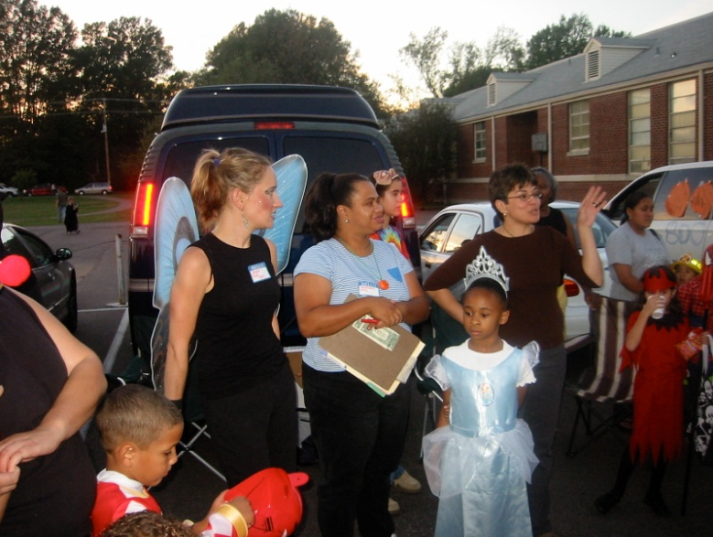

Please notice that our parents and guardians are described in this section, and in our organizational chart, as the foundation of our school. It’s true. We have to have parental involvement to have a great school. This section briefly describes how you can help make Berclair a great school by supporting your child’s education.

**Berclair’s Educational Support Team (PIE):**

Our PIE (Partners in Education) is made of parent and community volunteers that provide more than the traditional school fundraiser or PTA efforts. Our PIE organization provides our students wholesome activities like the Trunk or Treat, Holiday Canned Food Drive, Field Day, School Carnival, Student or Class Incentives, and the Berclair Bucks Program. Our PIE organization. also supports our teachers directly with critically needed supplies and equipment. There are many opportunities for you to volunteer at our school. We need volunteers to help us with the following: tutoring, operating student recognition and achievement events, mentoring, sports, art instruction, chaperoning field trips, classroom, library or office volunteers. Let us know if you have a specific talent or craft you would like to share with us. Please consider joining our PIE organization. Please sign up at the Open House, Family Night, or come by the school when it is convenient for you.

**Parental and Guardian Expectations:**

As you prepare to support your child and your child’s school this year, please refresh yourself with the expectations we at Berclair have for parents and guardians. Please note, our expectations for our students, ourselves, and our parents and guardians are high because we all want the best for our students.

**School Communications**

* Parents/guardians should always contact the teacher first, then the principal, whenever they need clarification for academic or social issues.
* Parents/guardians should check their child’s planner daily for homework, test schedules, and school news.
* Please schedule conferences with teachers in advance, unless in an emergency, so that the instructional time for all students can be protected.
* It is necessary for appointments to be scheduled with teachers. Impromptu meetings interfere with instruction and other required responsibilities of the teachers. Please contact the teacher to plan for meetings during planning periods or outside of the regular school day.

MCj02872990000[1]

MCj02403410000[1]

**Parental Support**

* Parents/guardians should join the Berclair PIE.
* Parents/guardians should show and model for their child that school is important by what they say about school and by volunteering their time to the school.

MCj03981530000[1]

**Student Attendance**

* Parents/guardians should make sure that their child is at school every day, on time, stays the whole day, and has the supplies he or she needs for school.
* If a child has to miss school, parents/guardians should always send a dated and signed note to school that explains why their child missed school.

**Academics**

* Parents/guardians should read to their child daily.
* Parents/guardians should get their child a library card and take their child to the library each month.
* Parents/guardians should ask their child daily what they learned at school and what questions they asked at school.
* Parents/guardians should provide their child, at the same time each day, a quiet space with good lighting for homework and study.

MCj03981370000[1]

**Attendance**

Tennessee law requires that all children between the ages of six (6) and seventeen (17) attend school. Regular and punctual attendance is essential for deriving maximum success from the instructional program. Higher academic achievement occurs when students attend school regularly.

*“You can’t play ball if you don’t show up at the game.”*

**Absences:**

Pupil absences shall be excused for the following reasons only:

* Personal illness of the student
* Death or serious illness in the immediate family of the student
* Validated court appearance of the student
* Recognized religious holiday/event
* Any other unusual cause acceptable to the principal (These reasons will include approved school sponsored/sanctioned activities.)

When your child returns to school, please send with him/her a signed and dated note that explains why your child was absent. If no note is sent that justifies the absence within three days, the absence will become an unexcused absence. Once a student has missed three days within the year, Berclair requires official documentation, such as a doctor’s note, for any absence to be excused.

Students shall be permitted to make up all work and tests missed as a result of an excused absence. Work and tests must be made up by the end of the current reporting period.

Being absent from school without a justifiable reason is called truancy. Truancy is a crime in Tennessee. Parents convicted of truancy are subject to a $ fine for each day the student is out of school. Parents may also have to perform community service for every day their student misses school.

**Late to School (Tardy):**

Students reporting to their morning class after 8:15 a.m. are late to school and are considered “Tardy.” Any student reporting after 8:15 a.m. must report to the office accompanied by the parent. Tardiness can be excused if the parent provides an acceptable written explanation. Students who are tardy miss valuable instruction. Please make every effort to have your child at school before 8:15 each day. Students arriving to school after 8:10 will not receive breakfast. Please ensure your child is on time if you are expecting them to eat breakfast at the school.

**Leaving School Early:**

Parents who request an early dismissal for urgent personal reasons must send a written request to the child’s teacher. To insure your child’s safety, children will not be released to other adults without the written permission from the parents or guardians. The person checking the student out must sign him/her out in the office. Students are not allowed to be checked out early from school from 2:45 p.m. to 3:15 p.m. unless there is a family emergency. Please do not check out your child upon returning from a field trip.

Once a student has been absent 3 (three) days in the year, official documentation (note from doctor’s office, dentist, government/court papers, etc.) is required by the principal for the absence to be excused. A note from the parent will not be accepted.

SWAG Incentive- In order to encourage good attendance, our students are offered the opportunity to SWAG-OUT on Fridays if they fulfill all three criteria. 1)Student must be present Monday-Thursday 2) Arrive on time 3) Not checked out early. This incentive will not begin until the 2nd quarter. We want our students to become established in wearing their school uniform. During the first quarter, students will be rewarded by activities determined by the school attendance team. Dressing in SWAG means that students may dress up or wear denim with their school spirit shirts or appropriate favorite shirt.

##### Academics

PLEASE NOTICE

PLEASE NOTICE

PLEASE NOTICE

The grading system for Shelby County Elementary Schools in accordance with the Tennessee Uniform Grading System establishes the grading system for grades kindergarten through fifth grade.

Two (2) report cards are used in grades K-5; (1) for kindergarten; (1) for grades 1-5. Teachers should refer to the appropriate card for an explanation of the grading system for each level.

**Kindergarten:**   
The kindergarten report cards show progress toward the state standards. The grade level standard is set by the state and indicates what a student should know and be able to do. Students are evaluated based on their progress toward meeting benchmarks for each standard. This is indicated by mastery or non-mastery for each skill. Report cards are sent home at the end of each nine-week term. The district is planning to move toward the use of portfolios.

**Grades 1-5:**   
In all schools, students' conduct is graded as “E”, “G”, “S”, “N”, or “U” and is to be reported at each grading period on the report card. Self-contained classes receive one homeroom conduct grade. Individual subject classes each give a conduct grade.

The basic grading system for knowledge / subject area is expressed by the letters “A”, “B”, “C”, “D”, and “F” with the following numerical values except for 1st grade science and social studies which will be expressed by the letter “S” or “N”.

Grading Scale: A = 93-100 D=70-74

B = 85-92 F=Below 70

C = 75-84

Teachers will post grades, at a minimum, once every two weeks. Progress Reports will be sent home in the middle of each nine weeks. It is highly recommended that all parents of students in grades 1-5 participate in the practice of checking PowerSchool every week rather than waiting for a progress report or a report card.

A student's academic grade is solely intended to reflect the student's acquired knowledge, ability, and/or skills in the designated subject. Therefore, academic credit / points may not be awarded or deducted for any purpose that is not directly related to the student's academic performance. For example, academic credit / points may not be awarded as an incentive to participate or achieve a certain goal in a school fundraising event. Academic credit / points may not be deducted for failure to purchase certain brands or types of school supplies. A reasonable number of academic points may be deducted from a student's academic grade for failure to submit homework or other assigned academic work on the date specified by the teacher.

Parents are to be notified within a report card period when a student is not doing acceptable work. Parent-teacher conferences should be held for gaining parental support in an effort to improve student performance.

Students in grades 1-5, will be assessed by the state for academic standards in English Language Arts and Mathematics periodically through testing that you will hear referred to as a benchmark test. These tests measure the progress of students throughout the school year.

**Grade Configurations:**

Many classes in Grades 1-5 are departmentalized or teamed. Some classes are self-contained. These students do not switch rooms or teachers during the day.

**Homework:**

During a typical week, the total time for completion of homework assignments should not exceed:

Kindergarten Average of 5-10 minutes/day

Grades 1-3 Average of 5-30 minutes/day

Grades 4-5 Average of 30-40 minutes/day

**Technology**:

j0195384

**Internet Acceptable Use Policy**

To gain access to e-mail and the Internet, all students must sign and return a permission form to the school office. Students are limited to use school computers for testing, research, and student communications. Computer use is considered a privilege and not a right. Students who abuse their use of school computers will lose their computer privileges.

Academic instruction is supported with high quality, scientifically based computer instruction. Emphasis on technology has caused us to install an additional computer lab. Parents are invited to access our computer lab. We will share instructional websites that will enable you to help your child. A parent may use it for personal use for things such as a personal job search or researching instructional material. Please call and let us know when you are coming (416-8800) and always check in at the office.

**Section 504:**

Section 504 of the Rehabilitation Act of 1937, as amended, is a civil rights law that prohibits discrimination against individuals with disabilities. The statute ensures that a qualified student with a disability receives reasonable accommodations necessary for that student to access education or school-related programs and activities.

Any child suspected of needing a Section 504 Plan should be referred to the Section 504 chairperson at Berclair, our school counselor. Our counselor will then start the process to see if the student meets the qualifications under this federal law.

**Reporting Student Academic Progress:**

Our teachers will try to communicate your child’s academic progress to you through the following means:

* Berclair Student Planners will be sent home daily with students and may contain messages from the teacher.
* Teachers may send home notes, send emails, or make phone calls to contact parents and guardians about their child’s academic progress as needed.
* Students will bring papers home in a Red Folder on Wednesday to be signed and returned to the teacher on Thursday.
* Parent/Teacher conferences
* Progress Reports
* Nine Week Report Cards
* Formative Assessment Results

##### Business Matters

**All Things Financial:**

**Books**

Fees will be charged for lost and damaged library and textbooks. Please encourage your children to take care of their books.

Field trips

In order to enrich our students’ lives, our school, on occasion, will offer a field trip. The charges for field trips cover the bus expense and the cost of admission. If your child misses the field trip for any reason, this money is non-refundable. Parents may be asked to chaperone a field trip for a variety of reasons including the safety of a child or if the student exhibits behavioral issues.

Before the field trip, teachers will send home a field trip form requesting the most current parent contact information such as telephone numbers for home, work and emergency contact information. Someone from the school will call and test this information before the trip. Your child may not attend any activity off campus without it. We are always interested in the safety of your child.

Insurance

Student insurance is offered to our students. Insurance applications are available at registration. Parents are encouraged to consider this offer.

**Student Planners**

Our planner is an organizational tool for our students. We have learned over time that students have better grades at school if they have and use planners. It is a great method for home and school communication. All families are strongly encouraged to use the planners.

**All Non-Financial Business:**

**Phone Calls**

We are not able to take phone calls for students. Students are not called out of class to take calls. Therefore, please make all travel plans with your children before they leave home each morning.

**Title One/Berclair Elementary Compact and Involvement Policy** Our school is a federally funded school-wide ESSA Title-One School. We receive additional school funding from our federal government based on the number of students eligible for free or reduced lunch. This funding comes with specific requirements from our government. One of the requirements is that the parents acknowledge the Engagement Policy and sign a compact, or agreement, that will show that parents, the school, and the students are aware that they all share in the responsibility of the educational process. These documents are jointly written. Title-One also requires that schools create a positive and supportive learning environment resulting in high levels of achievement for all students. Funds are available for academic programs and strategies, additional teachers and other personnel, staff development, materials, supplies, technology, and parent training.

**Transportation**

We ask you during school registration to declare whether your child will walk to school or be driven to school in a car, daycare van or bus. All transportation changes after school registration must be in the form of a note. We cannot take a transportation change over the phone for the safety of our students.

##### Counseling Services

Counseling is an integral part of the Berclair School program. Counseling services are available to all students. The counselors work with students individually, in small groups and in classrooms.

The school counselors are the chief advocate for children and a catalyst in facilitating a caring and supportive school environment for students, staff, and parents. The counseling program is designed to be preventive and developmental, as well as responsive to students’ immediate needs. The program's focus areas include career awareness and planning, goal setting, time management, study and test taking skills, decision making, safety, and personal and social development. The counselor coordinates resources and directs families and students to appropriate agencies when needed.

The school counselor is the chairperson of the **S-Team (School Support Team).** The S-Team is a multi-disciplinary team made up of the parent, teacher, counselor, and other appropriate school personnel who together engage in a problem solving process to focus on identifying barriers to learning for the individual student.

Parents are encouraged to contact our counselors, Ms. Dandridge or Ms. Calvin by dialing 416-8800 during school hours to schedule an appointment.

**Student Behavior**

**School Rules**

**Be respectful and safe**

**Use acceptable and positive language**

**Follow directions the first time given**

**Keep your hands, feet, and objects to yourself**

**Behavior Consequences:**

Please see the SCS Student Code of Conduct for specifics regarding student behavior and consequences.

**Positive Behavior Interventions & Supports:**

Positive Behavior Interventions & Supports (PBIS) is a collaborative approach to student support services. It includes the Berclair Discipline Plan for which a committee meets throughout the year. The committee reviews student office referrals and works to maximize students’ achievement by addressing the cognitive, behavioral, social, emotional, health, safety and alternative educational needs of all students. Please contact the school counselor to view the plan.

**Bullying:**

Bullying can be described as:

***"Any act that interferes with a student's education or performance that has the effect of physically harming a student or damaging his or her property, placing a student in reasonable fear of physical harm, or creating a hostile educational environment."***

Training with faculty on bullying prevention includes defining bullying/intimidation, recognizing early stages, and providing strategies for addressing was done in a professional development setting during August in-services. Training of students on bullying prevention is to be implemented by the school counselor with the support of classroom teachers.  Training can be done through classroom guidance, small group, and individual counseling as well as through regular classroom education practices throughout the school year.

**Conduct:**

**Conduct marks on our quarterly report cards are as follows**:

Grades K-5

E Excellent (Your child is exceeding behavioral expectations.)

S Satisfactory (Your child is doing fine.)

N Needs Improvement (Your child has had some challenges in behaving correctly.)

U Unsatisfactory (Your child has behavior challenges.)

**Conduct Systems and Jurisdiction**:

Each teacher or grade level develops, based on the developmental level of the students, a conduct system that can be justified by numbers. Students earn or lose points in some fashion that will give us an objective way to measure a student’s conduct for the quarter.

There is a school-wide policy for conduct that applies to students who have been home suspended from school and/or expelled. It is as follows:

Students automatically receive an N in conduct if they receive a total of 3 or more days of home suspensions within a school quarter.

Students automatically receive a U in conduct if they receive a total of 5 or more days of home suspensions within a school quarter or an expulsion.

However, students can earn an N or U during each quarter without suspensions or expulsions if they lose enough points in their class to justify the low conduct mark.

Please also note that conduct is measured during their class time and whenever else they are to school, on the way to school, or on the way to their homes. SCS policies 6022, 6046, and 6050 outline the district’s handling of student disciplinary incidents and our administration adheres to these and all other SCS policies.

**Dress Code:**

**Students are required to wear uniforms to school.**

**Berclair Colors**

Pants, skirts, jumpers, and shorts worn by students are to be khaki tan, Navy, or Black only. Blouses and shirts worn by students are to be a solid red or navy blue color only.

* **Tops**- (shirts, blouses) must be red or navy blue in color, with the same color collars and sleeves. Acceptable styles include Polo or golf-style shirts, Oxford or button-down dress shirts, blouses with Peter Pan collars. Long sleeves and short sleeves are both acceptable. Sleeveless tops are not acceptable.
* **Bottoms**- Acceptable pants styles include full-length dress pants, boot cut or straight-legged pants, cargo pants, straight-legged capri pants, cropped pants and knee-length walking shorts. Skirts or jumpers must also be knee-length or longer. Jeans, tight-fitting or baggy pants are not acceptable. If belts are worn, they must be fitted at the waist.
* **Shoes**- heels should be no higher than inch and a half; athletic or tennis shoes, as well as boots, are acceptable; if sandals are worn, they must have a heel strap.
* **Clothing should not have any visible logos.**
* **Outer Wear –** Light jackets, sweaters or sweatshirts are permitted to be worn inthe classroom if they are uniform colors. No heavy coats can be worn during the school day.

**Jurisdiction:**

Students are held accountable for their behavior on campus and at other specific places and situations as listed below:

1. On school grounds before, during, or after school hours and at any other time when the school is being used by a school group;
2. Off school grounds at a school activity, function, or event; or in a capacity of representing the school;
3. Traveling to or from school, a school activity, a school-related function, or school-related event;
4. Whenever a student engages in any contact with a school employee off or on campus, during or after school hours, and during or after the school year.

**Sexual Harassment:**

Student to student sexual harassment is a form of discrimination as set forth in federal law, Title IV of the Education Amendments of 1972. It is illegal and includes a wide range of behaviors. Student to student sexual harassment includes unwelcome actions causing a reasonable person to feel uncomfortable or unsafe resulting in a hostile, offensive, and or intimidating learning environment. It applies to opposite sex and same sex victims.

Examples of sexual harassment include, but are not limited to:

* unwelcome sexual flirtation or propositions
* offensive jokes, drawings, cartoons, graffiti, pictures or gestures
* making graphic comments about a person’s body or conduct
* sexually insulting remarks about race, gender, socioeconomic class, disability or sexual orientation
* spreading sexual rumors
* cornering/blocking normal movements, threatening or stalking behavior
* unwelcome physical contact including touching, patting or grabbing a person or their clothing
* unwelcome person-to-person contact including bumping and/or rubbing against a person
* sexually exposing oneself
* sexual battery or other

Any student (or parent/legal guardian) who believes he/she is experiencing student to student sexual harassment should report such circumstances to the teacher or principal immediately. The faculty and staff will be alert to assisting students, even when students do not ask for help.

Each student is responsible and will be held accountable for conducting himself/herself in a manner compliant with this policy.

##### Tennessee Department of Education Contact Information

**TENNESSEE 2004 SESSSION LAWS**

**2004 SESSION OF THE 103rd GENERAL ASSEMBLY**

Pub. Ch. 585

H.B. No. 2161

EDUCATION—ADMINISTRATION—POWERS AND DUTIES

AN ACT to amend Tennessee Code Annotated, Section 49-2-203, relative to the duties of local boards of education.

BE IT ENACTED BY THE GENERAL ASSEMBLY OF THE STATE OF TENNESSEE:

SECTION 1. Tennessee Code Annotated, Section 49-2-203(b), is amended by adding the following new subdivision:

<<TN ST 49-2-203>>

Include in student handbooks, or other information disseminated to parents and guardians, information on contacting child advocacy groups and information on how to contact the state department of education for information on student rights and services.

SECTION 2. Local education agencies shall not be required to replace existing supplies of handbooks in order to include the information required in Section 1 until such supplies are exhausted.

SECTION 2. This act shall take effect July 1, 2004, the public welfare requiring it.

Approved this 3rd day of May, 2004.

**Tennessee Department of Education Contact Information**

Answers to many questions and much helpful information may be obtained from the State Department of Education by calling 1-888-212-3162 or visiting http://www.tn.gov/education

Legal Services Division

Division of Special Education, Tennessee Department of Education

710 James Robertson Parkway

Andrew Johnson Tower, 5th Floor

Nashville, Tennessee 37243-0380

Phone: 615-741-2851

Fax: 615-253-5567 or 615-532-9412

West Tennessee Regional Resource Center

100 Berryhill Drive

Jackson, TN 38301

Phone: 731-421-5074

Fax: 731-421-5077

East Tennessee Regional Resource Center

2763 Island Home Blvd.

Knoxville, TN 37290

Phone: 865-594-5691

Fax: 865-594-8909

**Child Advocacy Group Contact Information**

In addition to the state and local resources available to parents and children, there are many agencies and organizations that offer support, information, training, and help in advocating for persons with disabilities in Tennessee.

A few of these organizations are listed below:

**The ARC of Tennessee** is on the Internet at http://www.thearctn.org/

Phone: 615-248-5878

800-835-7077

**Support and Training for Exceptional Parents (STEP)** is on the Internet at http://www.tnstep.org

|  |  |  |
| --- | --- | --- |
| West Tennessee:  (901) 726-4334 | Middle Tennessee:  (615) 463-2310 | East Tennessee:  (423) 639-2464 |

**Disability Law and Advocacy (TP&A)** is on the Internet at <http://www.dlactn.org/>

800-341-1660

**Tennessee Voices for Children** is on the Internet at http://www.tnvoices.org/

|  |  |  |
| --- | --- | --- |
| West Tennessee:  (Jackson Area)  Telephone: 731-660-6365 | Middle Tennessee:  (Nashville Area)  615-269-7751  800-6709882 | East Tennessee:  (Knoxville Area)  865-609-2490 |

To report suspected abuse or neglect DCS.Custrv@tn.gov

DCS (Dept. of Child Services)

855-209-4226

Berclair Elementary School

Schoolwide Family Engagement Plan

Revised 5-23-18

# *Schoolwide Plan*

## Family Engagement Plan

The Family Engagement Plan was **jointly developed with parents, agreed upon by parents, and distributed to parents and implemented** to establish the expectations for parental involvement. This plan is written at the school level in conjunction with board policy #6156. This policy/plan is an **understandable uniform format** that is **provided in a language the parents can understand**. The policy is **made available** to the **local community** and **updated periodically** to meet the **changing needs of parents** and **school**.

### **ESEA Family Engagement Plan**

The administrators, parents, staff and community strategically plan and implement ESEA requirements according to the guidelines set forth in the law. To ensure that our parents participate in the development and implementation of the school’s program, we will do the following:

* Make parents aware of ESSA and the school’s participation.
* Provide parents with student academic/social information and progress reports.
* Solicit feedback and suggestions from parents at parent meetings on decisions relating to the education of their children in a timely manner.
* Provide parents with a copy of the Family Engagement Plan.
* **Provide parents** with a **description** and **explanation of the curriculum** in use at the school, **forms of academic assessment** used to **measure student progress** and provide the **proficiency levels** students are expected to meet by using simple and direct language.
* Provide an informational bulletin board with current opportunities for parent involvement.
* Provide a **process** for parent to **submit comments** and concerns for school policy, procedures or **school wide program** (TSIPP) if they are not satisfied when the school makes the plan available to the district.
* Build capacity for involvement knowing that **parental involvement strategies** are **coordinated** and **integrated** with **parental involvement** strategies under other programs such as Head Start, Reading First, Even Start, Parents as Teachers, Home Instruction Program for Preschool Youngsters, State-run preschool programs and Title III language instructional programs.
* **Convene** and invite all parents to an **annual parent meeting** to inform of Title I requirements, school’s participation in Title I and the right of parents to be involved in the school.
* Provide **flexible number of meetings** with flexible times during the day and evening throughout the school year for parents to attend.
* Offer diverse parental training and workshops to build capacity for involvement by providing **materials and training** to help parents work with their **children to improve their achievement**, such as literacy training or technology training.
* **Involve parents** and community organizations and adopters in **planning, review** and **improvement** of programs for the **school parental involvement policy and joint development of the school wide program plan (TSIPP)** in an organized, ongoing and timely way.
* Develop jointly with parents, a parent-school compact showing how parents, schools and students share responsibilities. Disseminate the compact to all students/parents and acquire appropriate signatures.
* Encourage parents to regularly visit and take an active role in school planning and volunteer their services.
* Translate written information and provide translators for meetings and programs.
* **Per parent request**, opportunities for **regular meetings** to formulate suggestions and to participate, as appropriate, in **decisions relating to the education of their children**, and respond to any such suggestions as soon as practically possible.
* Parents will receive timely notification of parental involvement programs through newsletters, flyers, agenda and marquee sign.
* Provide **assistance** for **parents** to understand topics such as:
* **State’s academic content standards**
* **State student academic achievement standards**
* **State and local academic assessments**
* **How to monitor a child’s progress**
* **Work with educators to improve student achievement.**
* Build capacity for involvement
* **Educate staff** with the **assistance of parents** in the **value** and **contributions of parents**
* **Work with parents** on how to reach out to, **communicate with** and **work as equal partners**
* **Implement and coordinate parent programs**
* **Build ties** between parent and schools
* Provide other reasonable support for parent involvement activities per parent request. Ex. Childcare, transportation.
* Provide accessibility to local agencies and schools, to the extent practicable, shall **provide full opportunities** for the **participation** of **parents** with **limited English proficiency, parents with disabilities** and **parents of migratory children**, including providing information and school reports in a format and, to the extent practicable, **in a language parents understand**.

Berclair Elementary School Title I Compact

**2021-2022**

This compact has been jointly developed and agreed upon by the school, parents, students and staff to share responsibility for improving student academic achievement by developing a partnership to help children achieve the State’s high standards.

## Berclair School’s Responsibility:

# Principal Agreement

I support this form of parent involvement. Therefore, I shall strive to do the following:

* Provide a safe environment that allows for positive communication between the teacher, parent and student
* Recognize and applaud consistent attendance of students and staff
* Encourage students that they have the potential to be college bound
* Schedule parent-teacher conferences and a Title I annual meeting to discuss the school compact
* Provide a high quality curriculum and instruction in a supportive and effective learning environment
* Invite all parents to an annual meeting informing them of Title I requirements, the school’s participation in Title I and the rights of parents to be involved in the school
* Provide parents reasonable access to staff to volunteer, participate and observe in their child’s class.

Signature___________________________

# Teacher Agreement

As a teacher, I want all students to achieve. Therefore, I will strive to do the following:

* Provide high quality curriculum and instruction
* Keep parents informed about student progress through frequent progress reports
* Provide homework assignments that reinforce classroom instruction
* Provide assistance to parents if requested so that they may help students with assignments
* Provide ongoing communication with parents through Weekly Folders, Weekly Newsletter, School Marquee Sign and Easy Caller System
* Use a variety of teaching strategies to ensure that each student will succeed at some level
* Maintain a classroom environment that is conducive and responsive to learning
* Dedicate time to receive professional development to gain knowledge which will ensure student progress
* Encourage and acknowledge students’ effort
* Focus on enriched skills to promote academic growth towards proficiency and middle school readiness.

Signature___________________________

# Home Responsibility:

# Parent/Guardian Agreement

As a parent, I will be responsible for supporting my child’s learning. Therefore, I will strive to do the following:

* See that my child is punctual and attends school regularly
* Support the school in its efforts to maintain proper discipline
* Establish a time for homework and review it everyday
* Provide a quiet, well lighted place to study
* Encourage my child’s efforts and be available for questions
* Stay aware of what my child is learning by making periodic visits and volunteering in my child’s classroom
* Provide a library card for my child and visit the library to check out books
* Encourage a positive use of extracurricular time
* Read with my child and let my child see me read
* Attend annual Title I meeting and other informational meetings
* Join and be actively involved in the Volunteer group, PIE (Partners in Education)
* Communicate with teachers on an on-going basis.

Signature____________________________

# Student Agreement

As a student, I will work to the best of my ability. I will strive to do the following:

* Come to school daily with the necessary supplies and materials
* Wear uniforms everyday
* Complete and return homework assignments
* Give every assignment my best effort
* Show respect for my peers and all adults
* Follow the Student Code of Conduct behaviors outlined in the Code of Conduct Handbook
* Obey classroom rules and procedures.

Signature__________________________

**Parents Right to Know**

**All parents have the right to request the following:**

* A teacher’s professional qualifications, which includes: state qualifications, licensure, grade(s) certification, waivers
* A teacher’s baccalaureate and/or graduate degree, fields of endorsement, previous teaching experience
* A paraprofessional’s qualifications
* An assurance that their child’s name, address and telephone listing not be released to military recruiters

**All parents will receive information on the following:**

* Their child’s level of achievement in each of the state academic assessments
* Their right to public school choice, supplemental services and more effective involvement if their child’s school is identified for school improvement
* Their option to request a transfer to another school within the district if their child is the victim of a violent crime at school
* Their right to timely notifications that their child has been assigned, or has been taught for four or more consecutive weeks by, a teacher who is not highly qualified

**Community Resources:**

**Family Services of the Mid-South**

2430 Poplar

Memphis, TN 38112

(901) 324-3637

**Frayser Family Counseling Center**

2150 Whitney Ave.

Memphis, TN 38127

(901) 353-5440

**Paul Schwartz Center for Children and Families**

2100 Whitney Avenue

Memphis, Tennessee 38127

(901) 353-5440

**Exchange Club Family Center**

2180 Union Avenue

Memphis, Tennessee 38104

(901) 276-2200 (24 hour hot line)

www.exchangeclub.net

**Community Resources Database**

· www.memphislibrary.org

· Scroll to the bottom of page and click LINC/211

· Click on Community Resources Database at the top of the page

**Shelby County Schools Northeast Regional Health Clinic**

East High School

3206 Poplar Avenue

(901) 416 – 6230

Open Monday – Friday 7:30 am to 4:30 pm to all Shelby County Schools students (Pre K – 12).

**AVAILABLE CLINIC SERVICES**

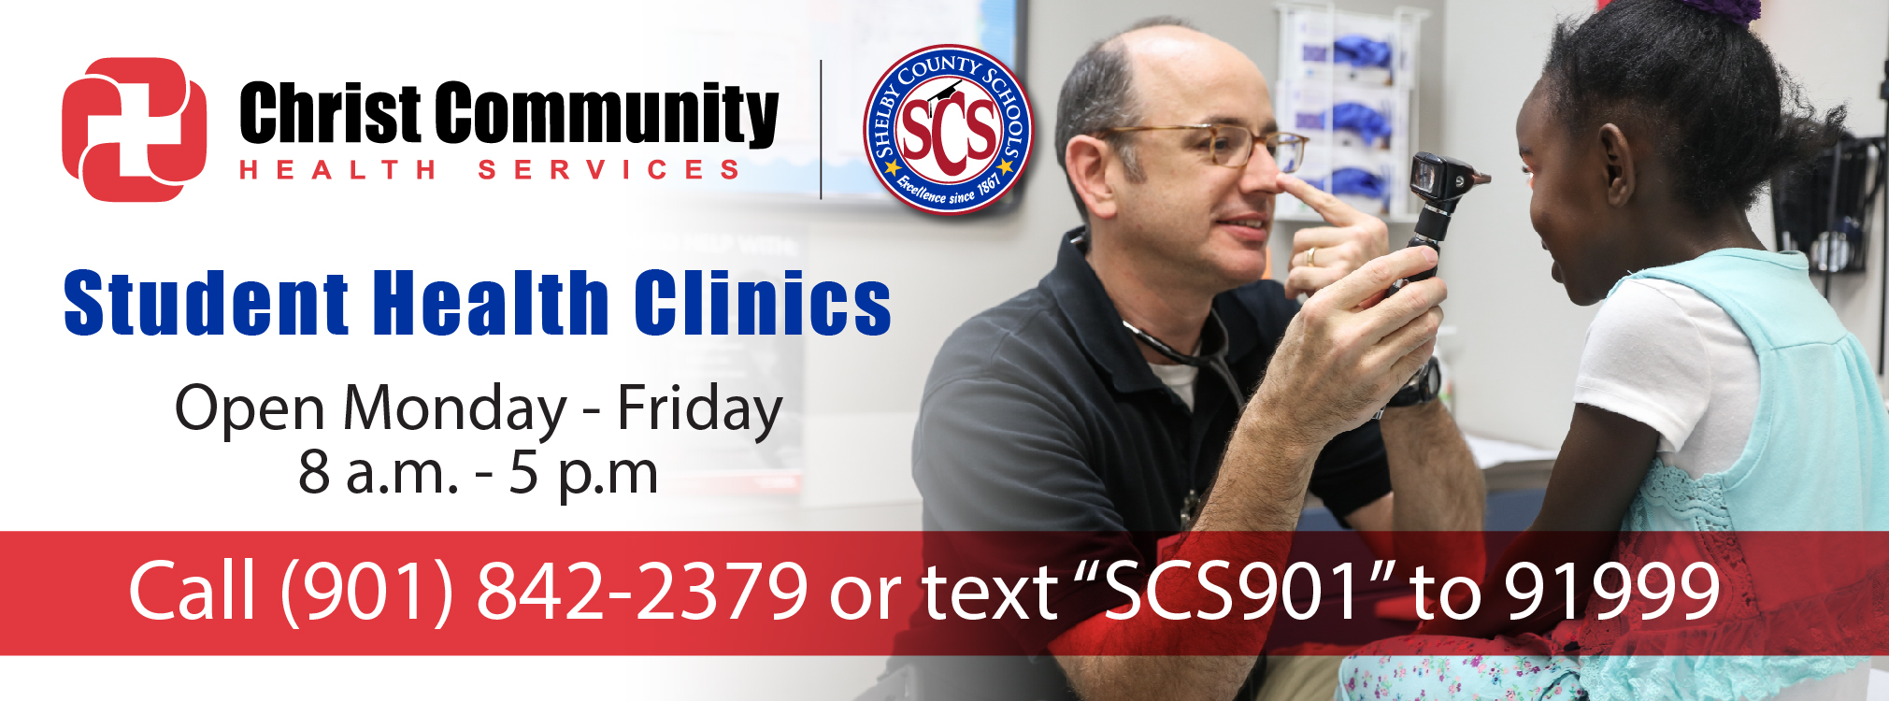

**School Based Clinic Locations:**

* **EAST HIGH SCHOOL -**3206 Poplar, Memphis, TN 38111 [**View Map**](https://www.google.com/maps/dir/''/EAST+HIGH+SCHOOL+3206+Poplar+Memphis,+TN+38111/data=!4m5!4m4!1m0!1m2!1m1!1s0x887f812dbba52b2b:0xa32153f8b657971c?sa=X&ved=0ahUKEwjq05W28azMAhVskYMKHR5LAIgQ9RcIdTAM)
* **SHEFFIELD CTC -**4350 Chuck, Memphis, TN 38118 [**View Map**](https://www.google.com/maps/dir/''/SHEFFIELD+CTC++4350+Chuck+Memphis,+TN+38118/data=!4m5!4m4!1m0!1m2!1m1!1s0x887f85e6f6b9e0f3:0x53b4c54ae0486693?sa=X&ved=0ahUKEwjGsPmE8qzMAhWKzoMKHWfRB-gQ9RcIczAL)
* **WESTWOOD HIGH SCHOOL -**4480 Westmont, Memphis, TN  38109 [**View Map**](https://www.google.com/maps/dir/''/4480+Westmont+Rd,+Memphis,+TN+38109/@35.0274197,-90.1251747,13z/data=!4m8!4m7!1m0!1m5!1m1!1s0x87d564b9cfff455f:0xf1f1130f02f86c7f!2m2!1d-90.0901553!2d35.0274247)

**Health Assessment/Physical Exams**

· Routine physicals and health screenings/checkups

· Sports, student employment, and college physicals

· Body Mass Index (BMI) and Blood pressure screening

**Diagnosis and treatment of minor injury and illness:**

· Coughs & Colds

· Sore throats

· Earaches

· Eye irritations

· Stomach Viruses/Stomach bugs

· Minor headaches

· Minor skin irritations, cuts, abrasions, sprains

· In-school injuries

**Laboratory Services / Screening:**

· Routine Blood Tests (Iron, sugar, cholesterol)

· Urine Tests

· Throat Cultures

**Wellness Promotion:**

· Immunizations

· Nutrition counseling

· Obesity education

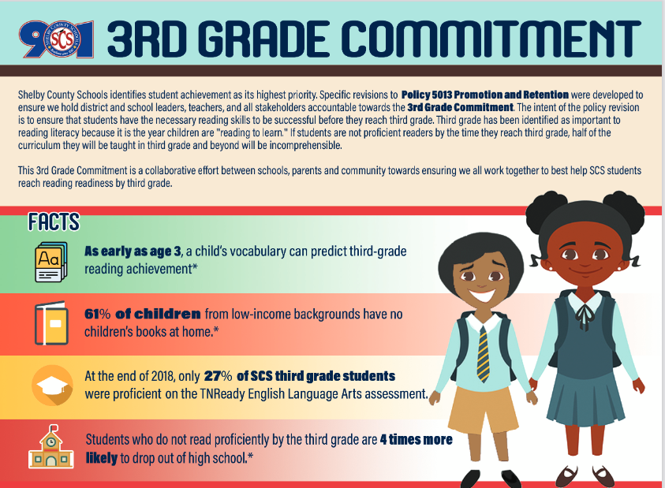

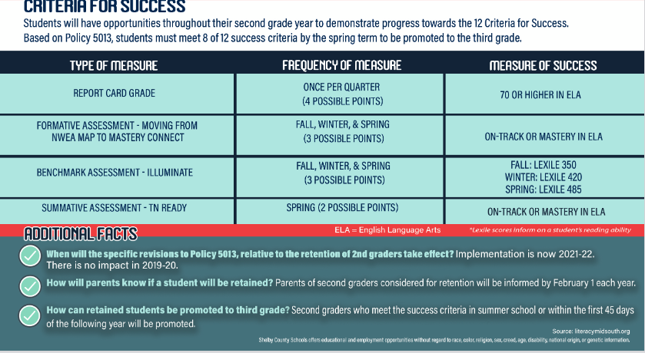

**Acknowledgement**

**Parents please initial all statements after you read through them and return this page to your child’s teacher within five (5) school days.**

I have received the 2021-2022 Berclair Elementary School Parent/Student Handbook. The handbook contains the Berclair Elementary Parent and Family Engagement Plan, Parent/Student/School Compact, and the Parent’s Right to Know.

I understand the benefits, responsibilities and penalties outline in the Berclair Elementary School Parent/Student Handbook.

I have read, understood, signed, and will support the Berclair Elementary School Parent/Student/School Compact.

I understand that my child will be held accountable for the behavior and consequences outlines in the Berclair Elementary School Parent/Student Handbook and the Shelby County Schools Code of Conduct at school and at all school-sponsored or related activities, regardless of time or location.

I have received a Berclair School Parent/Student handbook and will comply with all of the rules stated in the handbook.

Parent Signature Date

Student’s Name Grade (Please Print)